**Letter of Invitation**

Date: 8 Oct, 2022

To Visa Section

We are pleased to invite WANG Zhen, expert from NIO Co., Ltd, with Shanghai, to support NIO Norway.

The purposes of the visit are as follows:

* Purpose of visit 1: collect user needs, improve system design and R & D.
* Purpose of visit 2: need to communicate business pain points with business departments to help business landing.
* Purpose of visit 3: Actually participate in the whole process of sales and maintenance, and optimize the implementation of the process.

The planned dates & schedules are as follows:

17 Oct, 2022 – 7 Jan, 2023

|  |  |  |
| --- | --- | --- |
| Date | Place | What to do |
| 17 Oct, 2022 - 23 Oct, 2022 | Oslo | Confirm the R&D personnel on this trip to Europe, confirm the list of items that can be resolved locally, and clarify the way of collaboration with the Chinese team. |
| 24 Oct, 2022 - 6 Nov, 2022 | Oslo | Deal with problems encountered in the process of vehicle subscription and ensure that relevant problems are solved in a timely manner. |
| 7 Nov, 2022 - 20 Nov, 2022 | Oslo | Communicate problems related to Norwegian services to ensure that local closed-loop problems can be solved in a timely manner. |
| 21 Nov, 2022 - 27 Nov, 2022 | Oslo | Communicate with the local staff and purchase related issues, and work with the Chinese team to ensure that relevant issues are resolved in a timely manner. |
| 28 Nov, 2022 - 18 Dec, 2022 | Oslo | Communicate with local staff about logistics related issues, and work with the Chinese team to ensure that relevant issues are resolved in a timely manner. |
| 19 Dec, 2022 - 7 Jan, 2023 | Oslo | Communicate problems related to sales in Norway, improve the usability of the sales system, and solve some frontend and backend problems that can be quickly handled. |

Detailed information follows as below:

**Name:** Wang Zhen

**Gender:** MALE

**Nationality:** CHINESE

**Date of Birth:** Jan 13,1988

**Passport Number:** EJ6288007

Please grant a business visa for WANG Zhen to travel.

**NIO Co., Ltd.** will be responsible for all expenses incurred during the trip to and from Norway, including expenses for transportation, accommodation, travel insurance, as well as visa application.

We greatly appreciate the approval of this visa application at your earliest convenience. Should you need more information, please feel free to contact us.

Sincerely yours,

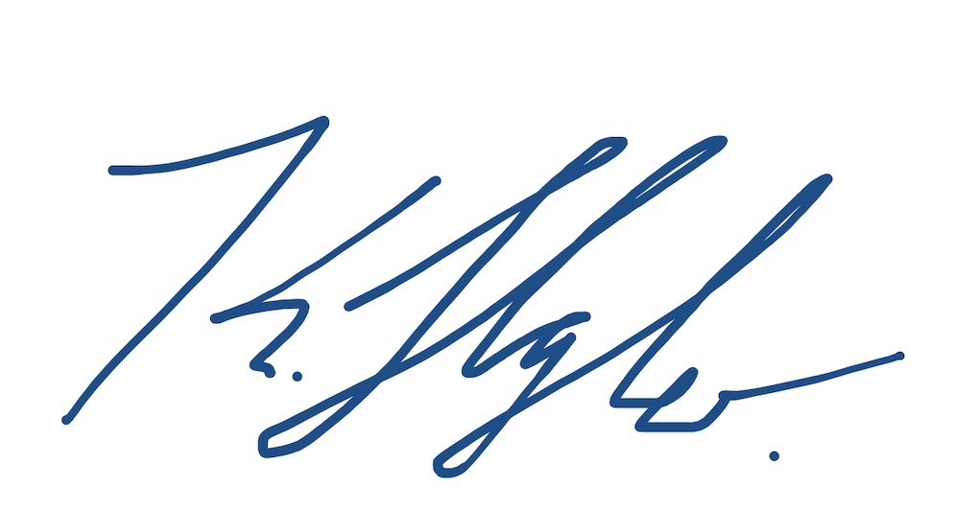

Marius Hayler

General Manager of NIO Norway

marius.hayler@nio.io

Tel: +47 905 51 411